PROJECT REPORT

On

AI-Driven Scheduling System for Academic Timetables
Submitted in partial fulfillment of the requirement for the Course COOP Module
of

COMPUTER SCIENCE AND ENGINEERING B.E.

Batch-2022



Under the Guidance of : Submitted By:
Dr.Shyam Goyal Sonakshi(2210990862)
Dev(2210990256)
Shashwat(2210992292)
Nikhil(2210991982)

DEPARTMENT OF COMPUTER SCIENCE AND ENGINEERING CHITKARA UNIVERSITY PUNJAB
CERTIFICATE

This is to certify that the project entitled “AI-Driven Scheduling System for Academic Timetables” has been successfully carried out by:
Sonakshi (2210990862)
Dev Rathi (2210990256)
Shashwat Sharma (2210992292)
Nikhil Singla (2210991982)
in partial fulfillment of the requirements for the degree of Bachelor of Computer Science Engineering at Chitkara University, Punjab, during the academic session January 2026 – May 2026, under the guidance of Dr. Shyam Goyal

CANDIDATE’S DECLARATION

We, Sonakshi (2210990862), Dev Rathi (2210990256), Shashwat Sharma (2210992292), Nikhil Singla (2210991982), G-10, B.E.-2022 of Chitkara University, Punjab, hereby declare that the Integrated Project Report entitled “AI-Driven Scheduling System for Academic Timetables” is an original work and the data provided in this study is authentic to the best of our knowledge. This report has not been submitted to any other Institute for the award of any other course.

ACKNOWLEDGMENT

It is our pleasure to express our gratitude to all those who directly or indirectly contributed to the successful completion of this project and influenced our learning throughout the course.
We sincerely thank Chitkara University, Punjab for providing us with the opportunity to undertake this Integrated Project as a part of our curriculum.
We are highly grateful to Dr. Shyam Goyal for his continuous support, guidance, and motivation throughout the project. His valuable suggestions, encouragement, and time greatly helped us in successfully completing this work.
We would also like to extend our appreciation to all faculty members and peers who supported us and provided useful insights during the development of this project.
Lastly, we thank our parents and friends for their constant encouragement, moral support, and valuable suggestions that helped improve the quality of our work.

Table of Contents
- Abstract
- Introduction to the project
  - Background
  - Problem Statement
  - Previous Research and Methodology
- Software and Hardware Requirement Specification 3.1Methods
3.2Programming/Working Environment 3.3Requirements to run the application
- Project LifeCycle
- Program Structure Analysis & GUI Design Considerations
- Code-Implementation
- Future Scope
- Conclusion
- References

Abstract

AI-Driven Scheduling System for Academic Timetables is a full-stack intelligent system designed to automate and optimize the process of academic timetable generation in educational institutions. The system efficiently allocates subjects, faculty members, classrooms, and time slots while ensuring that no scheduling conflicts occur. It also considers faculty preferences, workload balancing, and institutional constraints to produce high-quality timetables.
The platform provides a user-friendly interface where administrators can input data related to faculty, subjects, rooms, and constraints, and generate optimized timetables instantly. The system also supports data management, real-time updates, and scalability for future enhancements.
The system is based on advanced Artificial Intelligence techniques, combining Constraint Satisfaction Problem (CSP) modeling with Genetic Algorithm (GA) optimization to handle complex scheduling scenarios effectively.
Key Features of the System:
- Automates the entire timetable generation process, reducing manual effort and minimizing human errors.
- Implements a hybrid CSP + Genetic Algorithm approach to ensure conflict-free and optimized scheduling.
- Ensures strict enforcement of hard constraints such as no faculty or room clashes.
- Supports soft constraints like faculty preferred time slots and balanced workload distribution.
- Provides a user-friendly and interactive interface for managing scheduling data efficiently.
- Enables role-based access for administrators and users to ensure secure system operations.
- Ensures data security and integrity through structured database management and authentication mechanisms.
- Offers scalability with a modular architecture, allowing easy integration of future features and expansion.
- Generates timetables in seconds, significantly improving efficiency compared to traditional manual methods.
The AI-Driven Scheduling System enhances efficiency, accuracy, and reliability in academic timetable management, making it a practical solution for modern educational institutions.

Introduction

Background:

This project presents the development of an AI-Driven Scheduling System for Academic Timetables, designed to automate and optimize the process of timetable generation in educational institutions. Traditional manual scheduling methods are time-consuming, error-prone, and inefficient when handling multiple constraints such as faculty availability, subject allocation, and classroom management.
The proposed system acts as a centralized platform where administrators can efficiently generate conflict-free timetables while considering both institutional requirements and faculty preferences. It leverages Artificial Intelligence techniques by combining Constraint Satisfaction Problem (CSP) modeling with Genetic Algorithm (GA) optimization to handle complex scheduling scenarios effectively.
The system is supported by a scalable architecture with database integration and a user-friendly interface, enabling efficient data management and real-time updates. Ultimately, this solution enhances accuracy, reduces manual effort, and improves resource utilization, making it a practical tool for modern academic institutions.

2.2 Problem Statement
Academic timetable scheduling is a complex task that involves allocating subjects, faculty, classrooms, and time slots while satisfying multiple constraints. Many educational institutions still rely on manual or semi-automated methods, which are time-consuming, error-prone, and inefficient.
These traditional approaches often lead to issues such as faculty and room clashes, uneven workload distribution, and difficulty in managing large datasets or changing requirements. Additionally, existing systems lack scalability and flexibility to handle modern academic needs effectively.
The proposed AI-Driven Scheduling System aims to address these challenges by automating the timetable generation process using intelligent optimization techniques. The key problems addressed include inefficiency of manual processes, handling multiple constraints, lack of scalability, and frequent scheduling conflicts.
This system provides a more efficient, accurate, and reliable solution for modern academic timetable management.

Previous Research and Methodology

- The field of academic timetable scheduling has been widely researched, focusing on optimization techniques such as Constraint Satisfaction Problems (CSP), heuristic methods, and evolutionary algorithms like Genetic Algorithms (GA). Previous studies highlight the importance of handling multiple constraints, minimizing scheduling conflicts, and improving resource utilization through automated systems.
- Our project adopts a hybrid methodology by combining CSP modeling with Genetic Algorithm optimization to efficiently solve complex scheduling problems. The system is developed using Python for backend logic, along with database integration for structured data management and a user-friendly interface for interaction.
- The proposed approach focuses on generating conflict-free timetables, balancing faculty workload, and accommodating preferences while ensuring scalability and flexibility. This methodology enhances performance, reduces manual effort, and provides a practical solution for modern academic institutions

Software and Hardware Requirement Specification

Methods
    - The development of the AI-Driven Scheduling System follows an agile methodology, which focuses on iterative development, flexibility, and continuous improvement throughout the project lifecycle. The process begins with requirement gathering, where essential inputs such as faculty availability, subject allocation, classroom details, and institutional constraints are collected from stakeholders to define system functionality. This is followed by the design phase, where system architecture and user interface layouts are developed to ensure a simple and user-friendly experience for administrators. The development phase involves implementing the system using Python for backend logic, where Constraint Satisfaction Problem (CSP) and Genetic Algorithm (GA) techniques are applied to generate optimized timetables. A database is integrated to manage scheduling data efficiently. The system requires basic hardware such as a computer with a minimum of 4GB RAM and standard processing capabilities, along with software tools including Python, a database system, and a web interface for interaction.

Programming/Working Environment
The AI-Driven Scheduling System is developed using a combination of modern technologies to ensure efficiency, scalability, and performance. The backend is implemented using Python, which handles the core logic of the system, including Constraint Satisfaction Problem (CSP) modeling and Genetic Algorithm (GA) optimization for timetable generation. A relational database system such as MySQL is used to store structured data, including faculty details, subject information, classroom allocation, and scheduling constraints. For the frontend, a user-friendly interface is developed using web technologies to allow administrators to input data and visualize generated timetables effectively. Development tools such as Visual Studio Code are used for coding and debugging, while Git is used for version control and collaborative development. This environment ensures a reliable, scalable, and efficient system capable of handling complex scheduling tasks.

Requirements to Run the Application

Software Requirements:
- Python (Version 3.8 or higher): Required for executing backend logic and AI-based scheduling algorithms.
- Flask and Required Python Libraries: Installed using pip for API handling and system operations.
- React.js and Tailwind CSS: Used for building a responsive and interactive frontend interface.
- SQL Database (MySQL/PostgreSQL): Used for storing structured data such as faculty details, subjects, classrooms, and schedules.
- Web Browser: A modern browser such as Google Chrome, Mozilla Firefox, or Microsoft Edge for accessing the application.
- Operating System: Compatible with Windows, macOS, and Linux.
Hardware Requirements:
Server:
- Minimum 2 GB RAM and 20 GB storage for hosting backend and database.
- Internet-connected system for real-time data processing and access.
Client Machines:
- A standard PC, laptop, tablet, or mobile device with an internet connection.
- Minimum 2 GB RAM and a modern web browser for smooth operation.
These requirements ensure efficient performance, scalability, and seamless functioning of the AI-driven timetable scheduling system.

4 . Project Lifecycle:

The development of the AI-Driven Scheduling System for Academic Timetables follows the Agile methodology, emphasizing iterative progress, flexibility, and continuous improvement. The project is executed through the following key stages:
Requirement Gathering:
- Identification of system requirements such as faculty availability, subjects, classrooms, and scheduling constraints.
- Stakeholder interactions to understand academic needs.
Research:
- Analysis of existing scheduling systems and study of optimization techniques like CSP and Genetic Algorithms.
Design:
- System architecture design and workflow planning.
- Database schema design for managing scheduling data.
- API design for frontend-backend communication.
Development:
- Backend development using Python and Flask.
- Implementation of AI algorithms (CSP and Genetic Algorithm).
- Frontend development using React.js.
- Use of Git for version control and collaborative coding.
Integration:
- Frontend-backend integration.
- Database connectivity and synchronization.
Testing:
- Functional testing to verify system operations.
- UI/UX testing for usability.
- Validation of conflict-free timetable generation.
Deployment:
- Deployment of frontend and backend systems.
- Database hosting for real-time access.
Feedback and Iteration:
- Collection of user feedback.
- Continuous refinement and improvement of system performance.

5.Program Structure Analysis & GUI Design Considerations

The AI-Driven Scheduling System is designed using a modular architecture, where the entire system is divided into multiple functional modules to ensure better maintainability, scalability, and ease of development. The User Management Module handles user registration, authentication, and role-based access control for administrators and users. The Faculty and Subject Management Module manages all academic data, including faculty details, subjects, and their respective allocations. The Classroom Allocation Module ensures proper assignment of rooms based on availability and constraints. The core component of the system is the Timetable Generation Module, which uses Constraint Satisfaction Problem (CSP) modeling and Genetic Algorithm (GA) techniques to generate optimized, conflict-free schedules. The system also includes database management and API-based communication following an MVC architecture, ensuring efficient data flow and separation of concerns.
From a GUI perspective, the system is designed to provide a user-friendly and intuitive experience. The interface focuses on clear navigation, responsive design across devices, and consistency in layout and components. Role-based dashboards are implemented to provide customized views for administrators and users. Accessibility features and efficient data visualization, such as structured timetable displays, enhance usability and overall system performance.

6.Code-Implementation

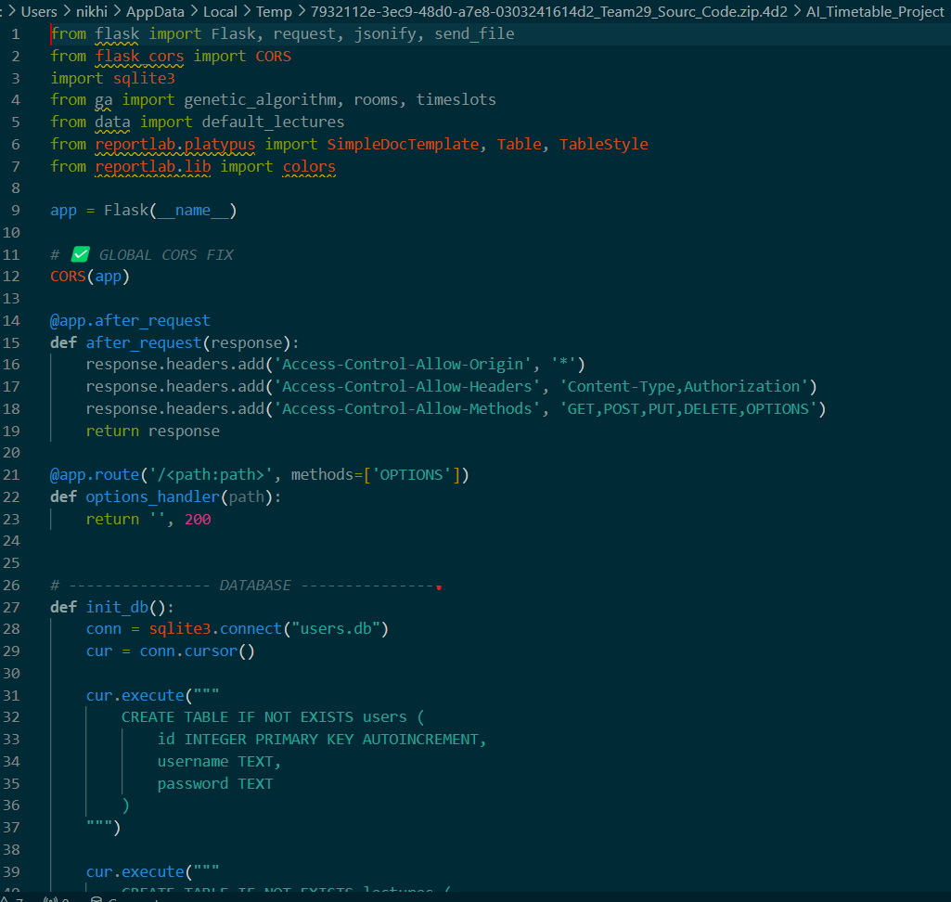

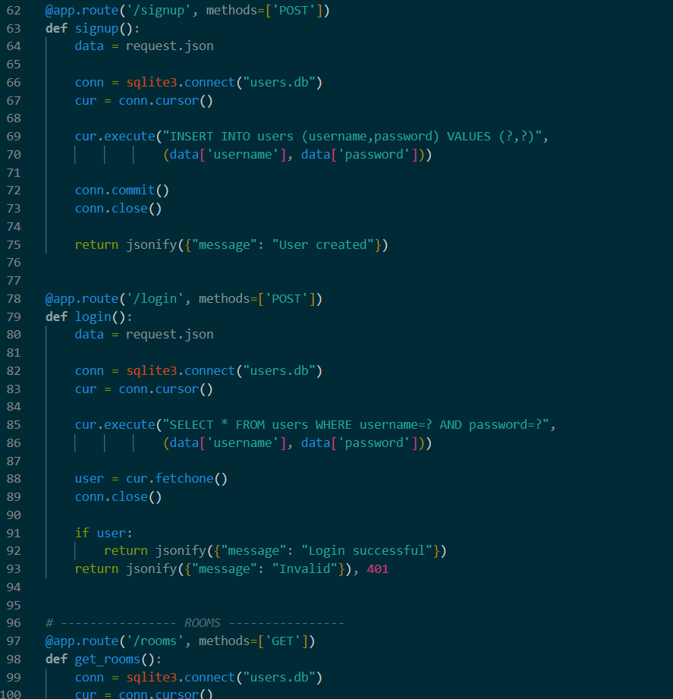
7.Future Scope

To further enhance the capabilities and performance of the AI-Driven Scheduling System for Academic Timetables, several improvements can be implemented in the future.
The system can be extended to support multi-department and multi-institution scheduling, enabling centralized management of timetables across different courses and campuses. Advanced analytics dashboards can be integrated to provide insights into faculty workload distribution, classroom utilization, and scheduling efficiency through visual reports and graphs.
Artificial Intelligence capabilities can be further improved by incorporating machine learning models to predict optimal scheduling patterns based on historical data and faculty preferences. Additionally, real-time updates and notification systems can be introduced to inform users about schedule changes instantly through email or mobile alerts.
Integration with institutional ERP systems can streamline academic operations by connecting attendance, examination schedules, and student records. Enhanced security features such as role-based access control and data encryption can be implemented to ensure data privacy and protection.
The system can also be deployed on cloud platforms to improve scalability, accessibility, and performance. With these advancements, the system can evolve into a comprehensive, intelligent, and highly efficient academic management solution.

8.Conclusion

The AI-Driven Scheduling System for Academic Timetables successfully addresses the limitations of traditional manual scheduling methods by introducing an automated, efficient, and intelligent solution. By utilizing advanced Artificial Intelligence techniques such as Constraint Satisfaction Problem (CSP) and Genetic Algorithm (GA), the system is capable of generating optimized and conflict-free timetables while effectively handling multiple constraints, including faculty availability, classroom allocation, subject requirements, and workload distribution.
The system significantly reduces the time, effort, and complexity involved in timetable creation, while minimizing human errors and improving overall accuracy. Its modular architecture and scalable design allow it to adapt to the dynamic needs of educational institutions, making it suitable for both small-scale and large-scale implementations. The integration of database management and a user-friendly interface further enhances usability, enabling administrators to manage scheduling data efficiently.
In addition, the system demonstrates the practical applicability of AI-based optimization techniques in solving real-world problems, particularly in the domain of academic administration. It also lays the foundation for future enhancements such as predictive scheduling, real-time updates, and integration with institutional ERP systems.
Overall, the project delivers a reliable, flexible, and high-performance solution that improves resource utilization, ensures fairness in workload distribution, and enhances the overall efficiency of timetable management. This work highlights the importance of intelligent automation in modern education systems and contributes to the advancement of smart academic infrastructure.

9.REFERENCES
- Burke, E. K., & Petrovic, S. (2002). Recent research directions in automated timetabling. European Journal of Operational Research, 140(2), 266–280.
- Carter, M. W., & Laporte, G. (1996). Recent developments in practical course timetabling. Proceedings of the 2nd International Conference on the Practice and Theory of Automated Timetabling.
- Goldberg, D. E. (1989). Genetic Algorithms in Search, Optimization, and Machine Learning. Addison-Wesley.
- Russell, S., & Norvig, P. (2010). Artificial Intelligence: A Modern Approach (3rd Edition). Prentice Hall.
- Schaerf, A. (1999). A survey of automated timetabling. Artificial Intelligence Review, 13(2), 87–127.
- Python Software Foundation. (2024). Python Documentation. Retrieved from https://www.python.org
- Flask Documentation. (2024). Flask Web Framework. Retrieved from https://flask.palletsprojects.com
- React Documentation. (2024). React Official Docs. Retrieved from https://react.dev
- MySQL Documentation. (2024). MySQL Reference Manual. Retrieved from https://dev.mysql.com
- Mitchell, M. (1998). An Introduction to Genetic Algorithms. MIT Press.

